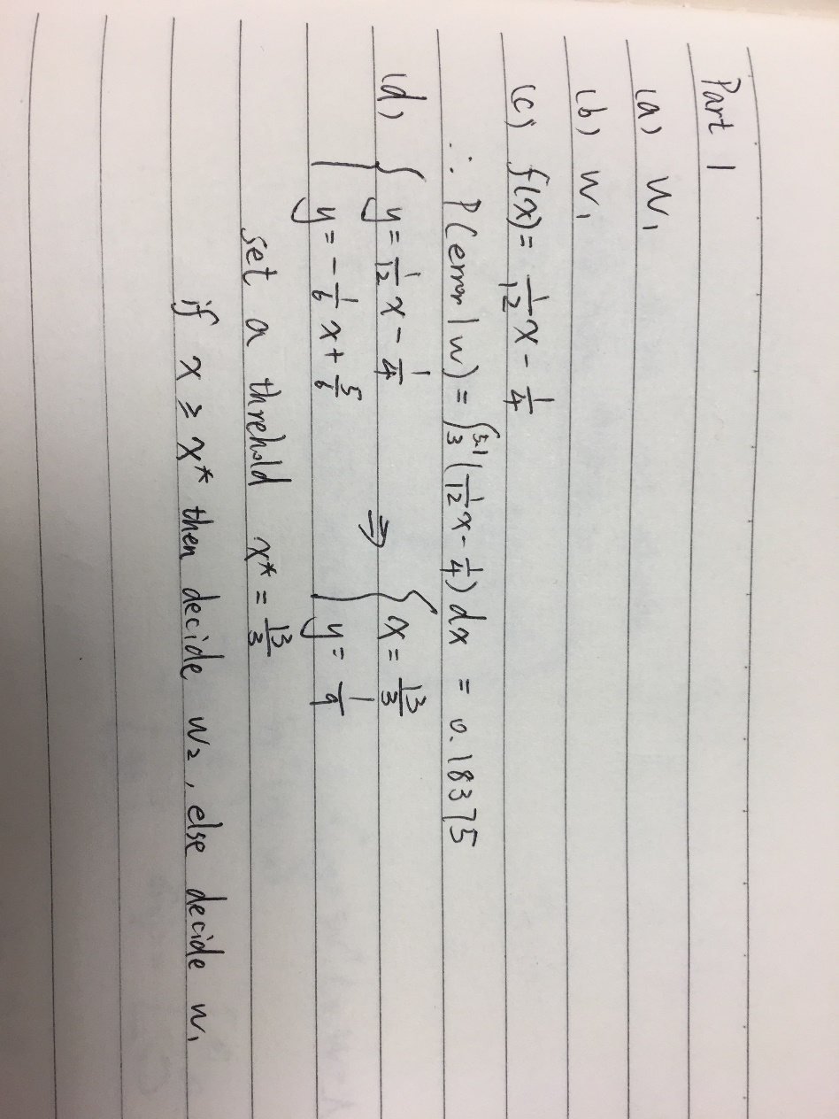

Part 2

1. PCA confusion matrix

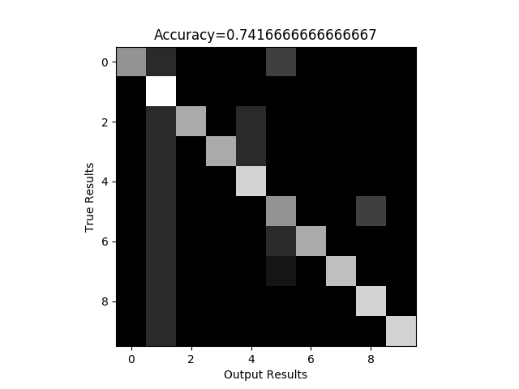

1. Eigenfaces and mean face

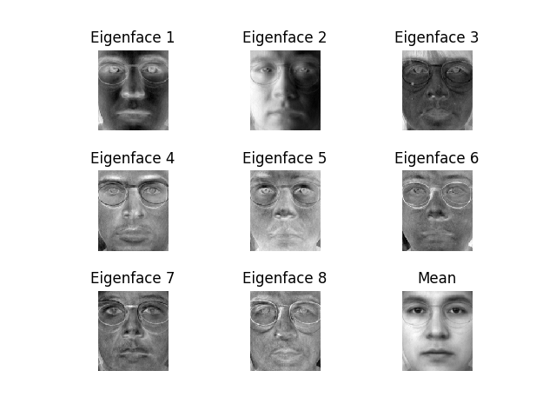

1. LDA confusion matrix

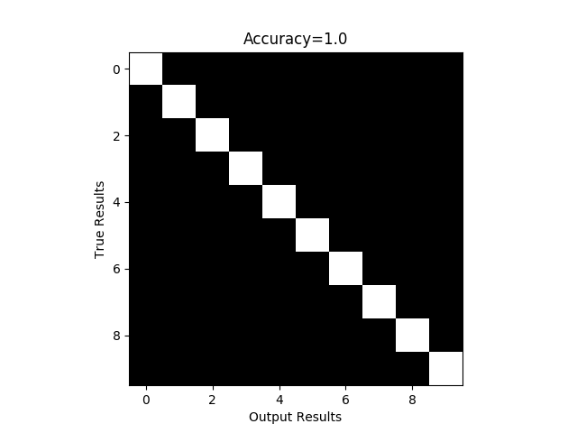

1. LDA centers

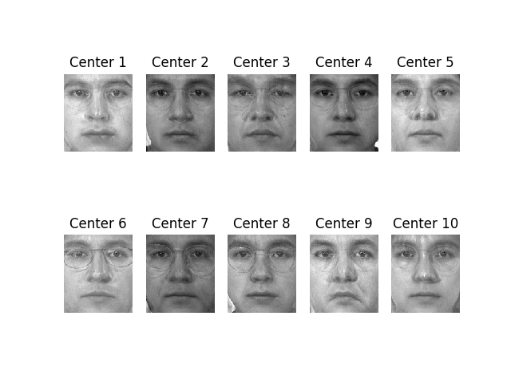

1. Fusion scheme confusion matrix

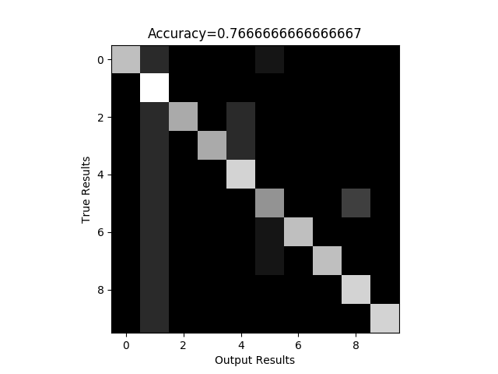

Q: Compare the results for PCA feature and LDA feature, which feature is better? Why?

A: LDA feature is better. In this problem, PCA just projects the data to the axis which is easy to present and it doesn’t use the information of classes within the data. So classes are mixed up which makes it difficult to classify. However, LDA finds the most suitable way to project the data so that classes are well separated. Thus, in this face recognition problem, LDA performs better.

Q: Let alpha = 0.1; 0.2; : : : ; 0.9. Retrain your identifier for fused feature and re-calculate its

accuracy for each alpha. Plot accuracy versus alpha for different alpha. Submit this plot. What do you observer?

A: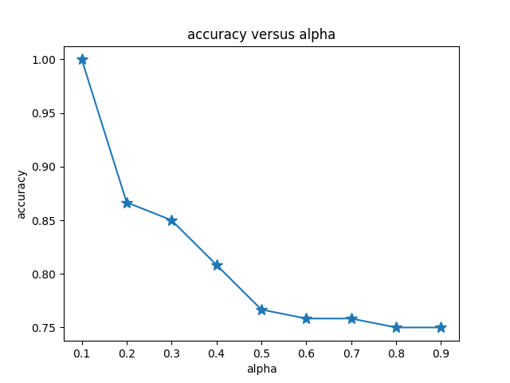

I find that with alpha increasing, the accuracy rate keeps dropping. When alpha tends to be 0, the accuracy tends to be 100% and when alpha tends to be 1, the accuracy tends to be 74%. For all the alpha between 0 and 1, the accuracy rate monotonically decreases.

Q: Does the fused feature outperform both PCA feature and LDA feature? Why?

A: No. This may because I just implement fusion scheme in feature level and it just do the combination of two feature vectors. Thus, the accuracy, unsurprisingly just between two methods and the limiting cases meet the results which I get above.